For the final submission to the e-mail pulse@unige.it, please name the file, in Word format, as follows “CfC PULSE_Author Name(s)”.
Please delete this text in the final version of your contribution.

TITLE
[Roboto Mono, Bold, 14]

SUBTITLE
[Roboto Mono, Bold, 12]

Author/s
Name, Surname
Affiliation
E-mail
[Roboto Mono, Italics, 12]

Research Field
(please select at least one)
- New Words
- New Maps
- New Strategies

Text
[Roboto Mono, Regular, 12, testo giustificato, APA Style]
The short abstract, in English, should have a maximum length of 4,000 characters, spaces included.

Regular, Italics, Bold
The abstract should all be written in Regular format. Italics are used to draw attention to key terms and phrases when providing definitions and to format e.g. book and/or journal titles. Boldface is not allowed (except for title and subtitle).
High inverted commas (‘ ‘) are used to present language examples and chapter titles of books and articles in the text.
Double low inverted commas, also called corporal (“ “), are used in direct speech, to explicitly quote words or text passages by other authors.

Citations in the Text (APA Style)
The reference to author and year must be explicit and placed in brackets before the punctuation mark ending the sentence (full stop or other).

EXAMPLE
La comunicazione tra culture differenti pone importanti questioni di carattere etico che occorre esaminare attentamente (Fabris, 2004).

EXAMPLE (2 authors)
(Walker & Allen, 2009)

EXAMPLE (organisations or institutions)
(Active Learning Network for Accountability and Performance in Humanitarian Action [ALNAP], 2018).

In the case of direct quotations of passages by other authors, which are quoted in the abstract in capital commas (« »), the exact passage and the author's first and last name and year must be specified in brackets after the punctuation mark ending the sentence. The article or book from which the quotation comes will be included in the bibliography at the end of the abstract (see instructions on next page).

EXAMPLE
«Its context is what gives a building its meaning. and consequently, change in context cause change in meaning». (Robert Venturi, 1966)

Figure
The figure in the text should be inserted as in the example below and with the correct caption. A maximum of 1 figure may be inserted in the abstract.
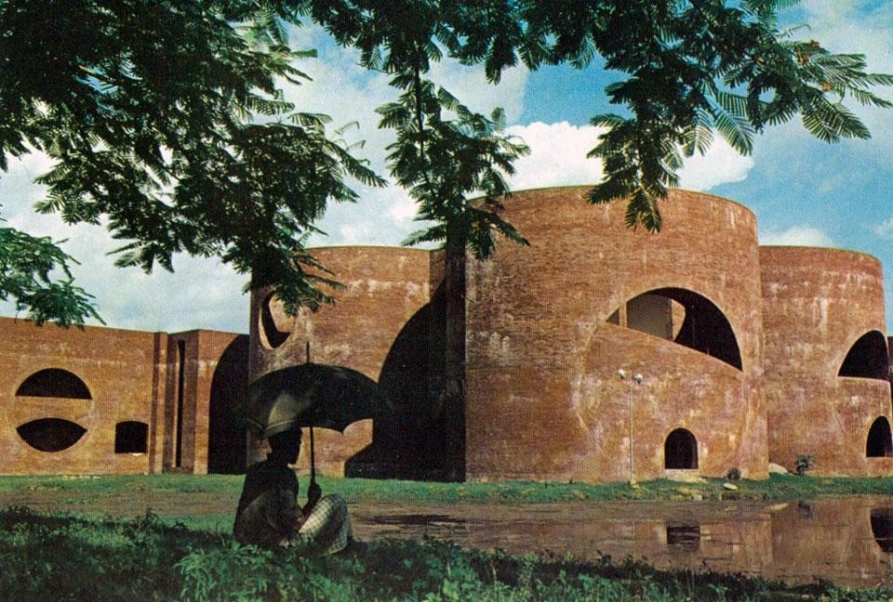

Louis I. Kahn, Ayub National Hospital and Medical College, Dhaka, Bangladesh. Photo: Anwar Hosain. Source: Domus 548 / luglio 1975.

References
[Roboto Mono, Regular, 11, APA Style https://it.bul.sbu.usi.ch/learning/apa_date#lea-apa-la-bibliografia]

The following are examples of the main rules for writing and organising the bibliography according to the type of references used. Any source must be verified, especially if it comes from the web or social media.

Single author
Frederickson, H. G. (1997). The spirit of public administration. Jossey-Bass.

Authors
Airoldi, G., Brunetti, G., & Coda, V. (2007). Corso di economia aziendale. Il mulino.

Books in electronic format
Rabinowitz, F. E. (2019). Deepening group psychotherapy with men: Stories and insights for the journey. American Psychological Association. https://doi.org/10.1037/0000132-000

Articles within books
Hinchliffe, L. J. (2008). Future of information literacy. In C. N. Cox & L. E. Blakesley (Cur.), Information literacy instruction handbook (pp. 230-235). ACRL.

Articles in journals/magazines
Light, M. A., & Light, I. H. (2008). The geographic expansion of Mexican immigration in the United States and its implications for local law enforcement. Law Enforcement Executive Forum Journal, 8(1), 73-82.

Online Articles
Carey, B. (2019, 22 marzo). Can we get better at forgetting? The New York Times. https://www.nytimes.com/2019/03/22/health/memory-forgetting-psychology.html

Encyclopaedias and Dictionaries
Konijn, E. A. (2008). Affects and media exposure. In W. Donsbach (Cur.), The international encyclopedia of communication (Vol. 1, pp. 123-129). Blackwell.

Wikipedia
Caloris planitia. (2019, 30 maggio). In Wikipedia. https://it.wikipedia.org/w/index.php?title=Caloris_Planitia&oldid=105217871

Web Pages
British Library. (n.d.). The slave trade: A historical background. http://www.bl.uk/learning/histcitizen/campaignforabolition/abolitionbackground/abolitionintro.html

Post, Blog, Social media
Facebook
Gaiman, N. (2018, 22 marzo). 100,000+ Rohingya refugees could be at serious risk during Bangladesh’s monsoon season. My fellow UNHCR Goodwill Ambassador Cate Blanchett is [Immagine allegata] [Aggiornamento di stato]. Facebook. http://bit.ly/2JQxPAD

Instagram
Alarez, S. [@salvarezphoto]. (2019, 23 giugno). Basin and Range national monument [Fotografia]. Instagram. https://www.instagram.com/p/BzDx80fpS_g/

